Assignment 1: Java Installation & Core Concepts
Name: Akshansh Rathore
Course: Java Programming Assignment 1
Date: 31/July/2026

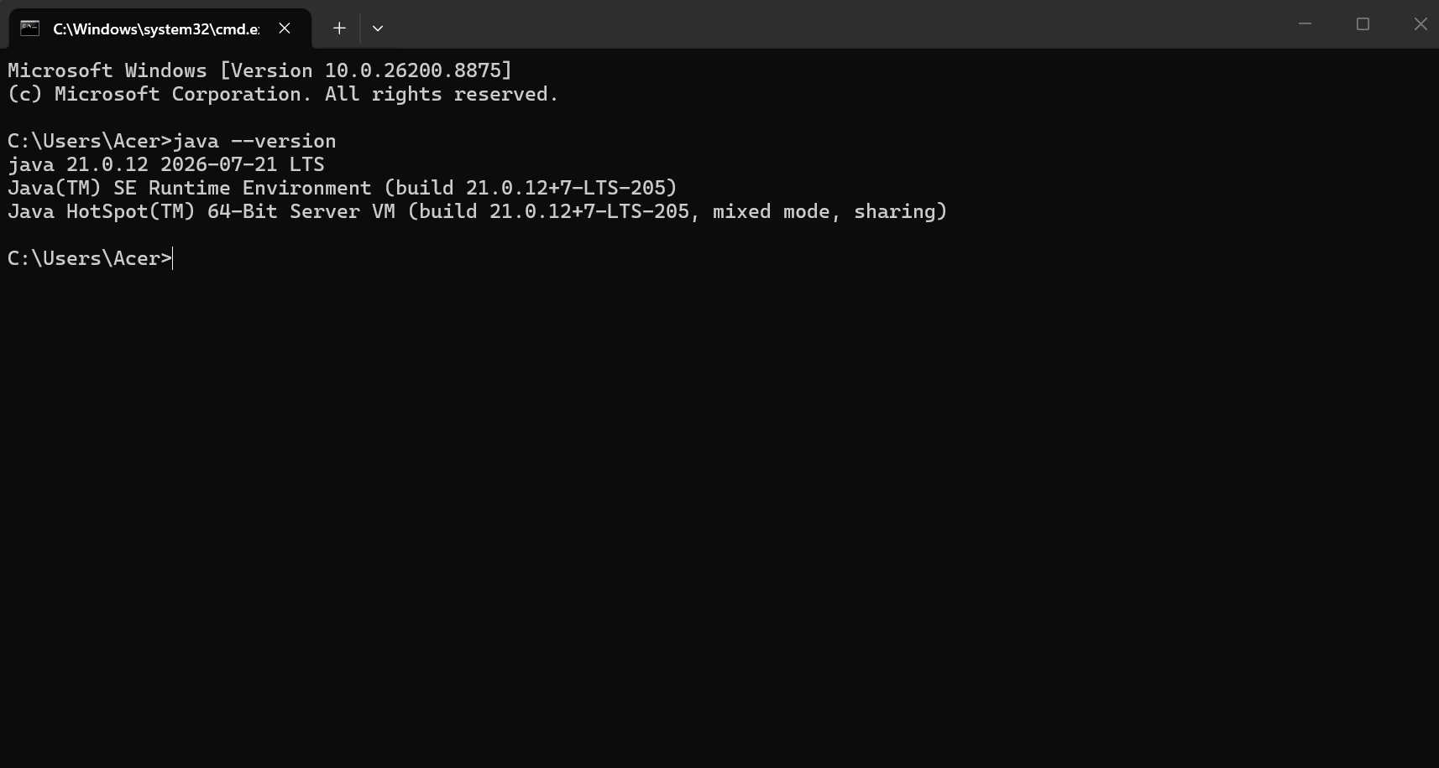
Java Version:

1. What is JDK?
JDK (Java Development Kit) is a software development environment used by programmers to develop Java applications. It includes the Java Runtime Environment (JRE), the Java compiler (javac), debuggers, and other essential tools. In short, the JDK provides everything required to write, compile, and execute Java programs.
2. What is JVM?
JVM (Java Virtual Machine) is the core execution engine responsible for running Java bytecode. It converts platform-independent Java bytecode into native machine code so the host operating system can execute it. The JVM enables Java's "Write Once, Run Anywhere" (WORA) capability and automatically manages memory through garbage collection.
3. What is JRE?
JRE (Java Runtime Environment) is a software package that provides the runtime environment and resources needed to execute compiled Java programs. It consists of the JVM, standard Java class libraries, and supporting runtime files. Unlike the JDK, the JRE does not contain development tools like compilers or debuggers.
4. Difference between JDK, JRE, and JVM
- Relationship & Composition:
  - JDK is the top-level package containing development tools and the JRE.
  - JRE sits inside the JDK, containing class libraries and the JVM.
  - JVM sits inside the JRE as the actual execution engine.
- Primary Function:
  - JDK is used to write and compile Java source code into bytecode.
  - JRE creates the environment required to run the compiled bytecode.
  - JVM executes the bytecode line-by-line on the specific operating system.
- Target Audience:
  - JDK is designed for software developers building applications.
  - JRE is designed for end-users who only need to run existing Java applications.
  - JVM is an internal engine operating under the hood during program execution.

